***3 ReactJS-HOL***

Create a react app for Student Management Portal named scorecalculatorapp and create a function component named “CalculateScore” which will accept Name, School, Total and goal in order to calculate the average score of a student and display the same.

1. Create a React project named “scorecalculatorapp” type the following command in terminal of Visual studio:



1. Create a new folder under Src folder with the name “Components”. Add a new file named “CalculateScore.js”
2. Type the following code in CalculateScore.js

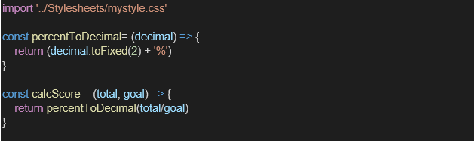

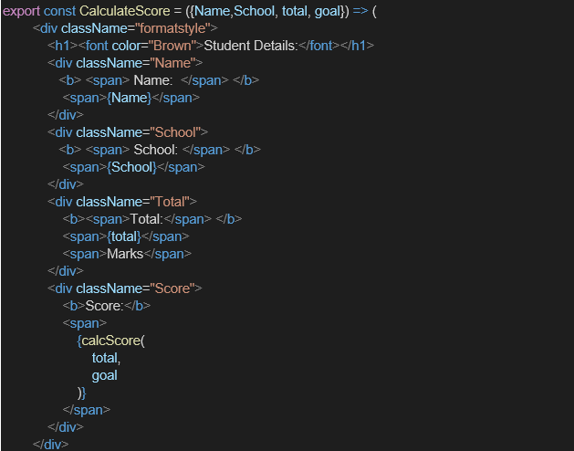

1. Create a Folder named Stylesheets and add a file named “mystyle.css” in order to add some styles to the components:

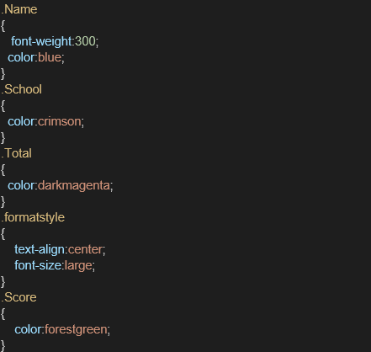

1. Edit the App.js to invoke the CalculateScore functional component as follows:

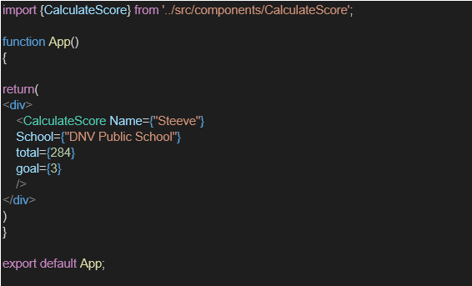

1. In command Prompt, navigate into scorecalculatorapp and execute the code by typing the following command:



1. Open browser and type “localhost:3000” in the address bar:

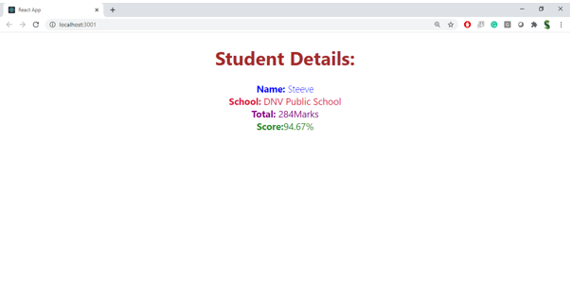

***Create a React project named “scorecalculatorapp”***

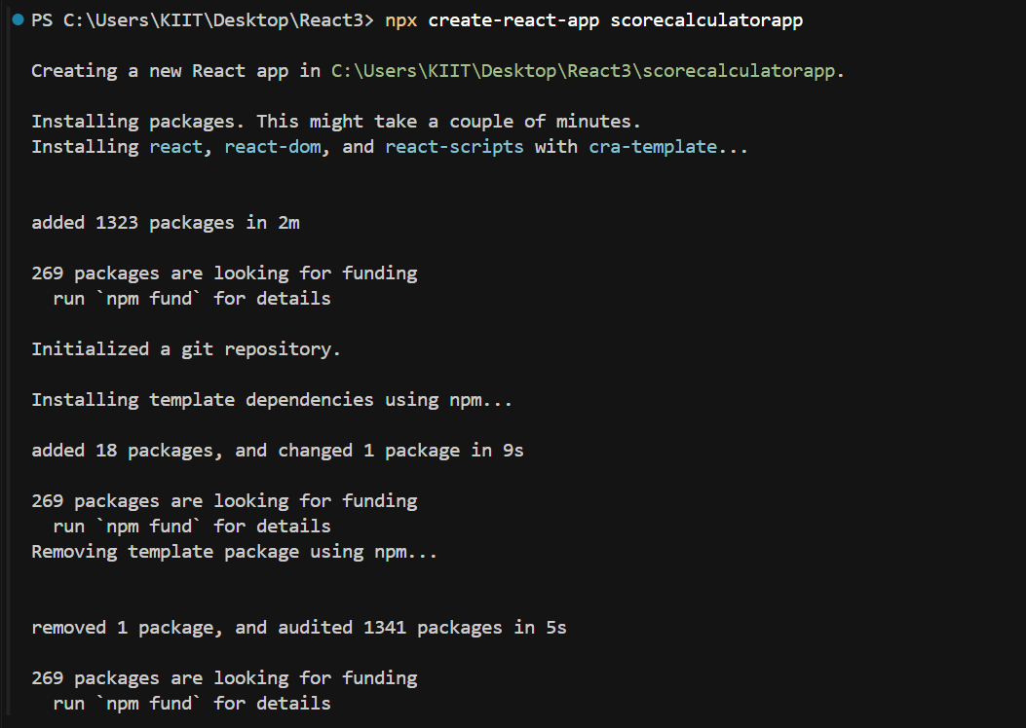

***CalculateScore.js***

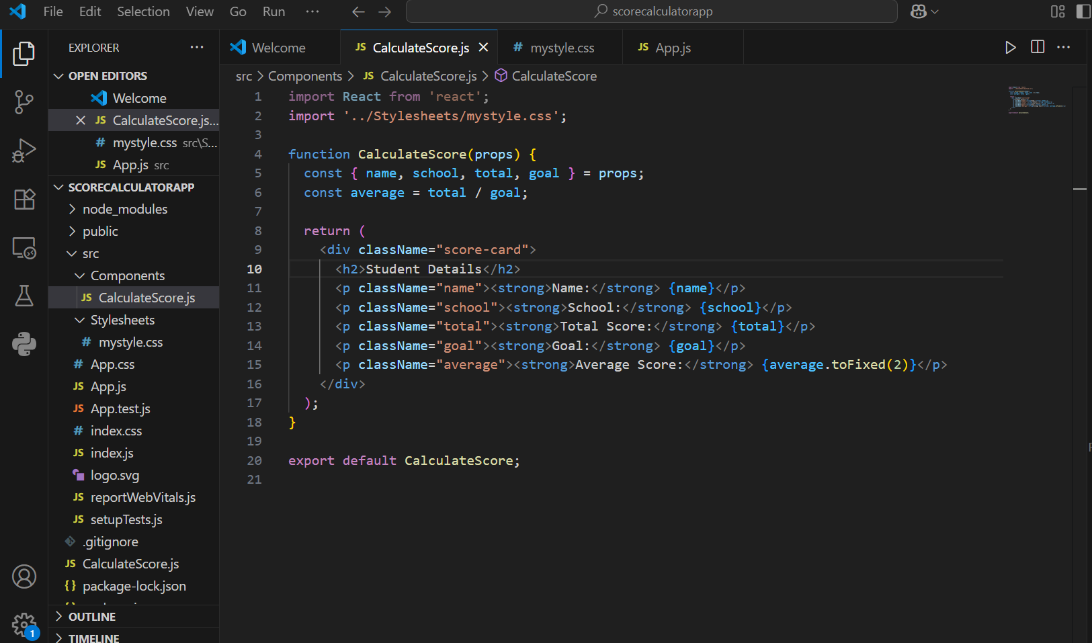

***mystyle.css***

.score-card {

  margin: 30px auto;

  padding: 20px;

  width: 400px;

  border: 2px solid #4CAF50;

  border-radius: 10px;

  box-shadow: 2px 2px 10px rgba(0,0,0,0.1);

  background-color: #f9f9f9;

  font-family: Arial, sans-serif;

  text-align: center;

}

.score-card h2 {

  color: #4CAF50;

  margin-bottom: 15px;

}

.score-card .name {

  color: blue;

}

.score-card .school {

  color: crimson;

}

.score-card .total {

  color: darkmagenta;

}

.score-card .goal {

  color: orange;

}

.score-card .average {

  color: forestgreen;

}

.score-card p {

  font-size: 16px;

  margin: 5px 0;

}

***App.js***

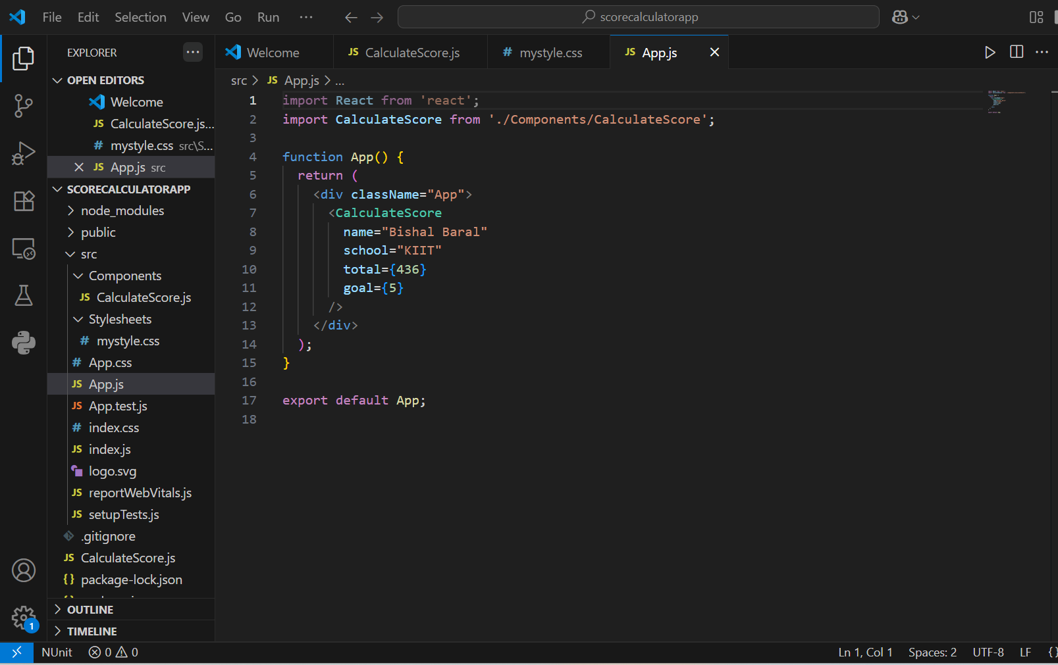

***Final Result***

